Oscillations:
Motion of a body is said to be oscillatory if it moves between two positions repeatedly making to and fro motion.
Ex: (1) A simple pendulum.
(2) A mass attached to one end of a spring and pulled down Periodic Motion:
Any motion, which repeats itself in regular intervals time is called periodic motion
Ex: all oscillatory motions and rotatory motions
Amplitude (A): It is the maximum displacement of the oscillating body from mean position.
Period (T): The time taken for one oscillation or one vibration or one rotation is called period
Frequency (f): It is the number of rotations or vibrations per second it is measured in a unit called
1 rotation
Hertz- (Hz) 1hz =
1 second
1 1
Note: T = or f  f T
Period of a second hand in the watch is 60.s. there fore frequency of a second hand in the watch 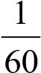 Hz
2 1  ¹ 
Angular frequency () = = 2 = 2 f   f 
T T  T 
It is expressed in an unit radian per second
Simple Hormonic Motion (SHM):
Simple harmonic motion can be defined as “Simple harmonic motion as a motion in which the acceleration is directly proportional to the displacement and acceleration is directed towards the mean position”.
Ex: A simple pendulum pulled aside by a small displacement executes linear SHM. Characteristic of simple harmonic motion:
- S.H.M is a periodic motion
- The maximum displacement of the body towards one side of the central position is called amplitude
- During the motion the acceleration of the body is always directed towards the mean position
- The velocity of the oscillating body does not remain constant during its motion 5) There is a restoring force continuously acting on the body.

Equation of simple harmonic motion
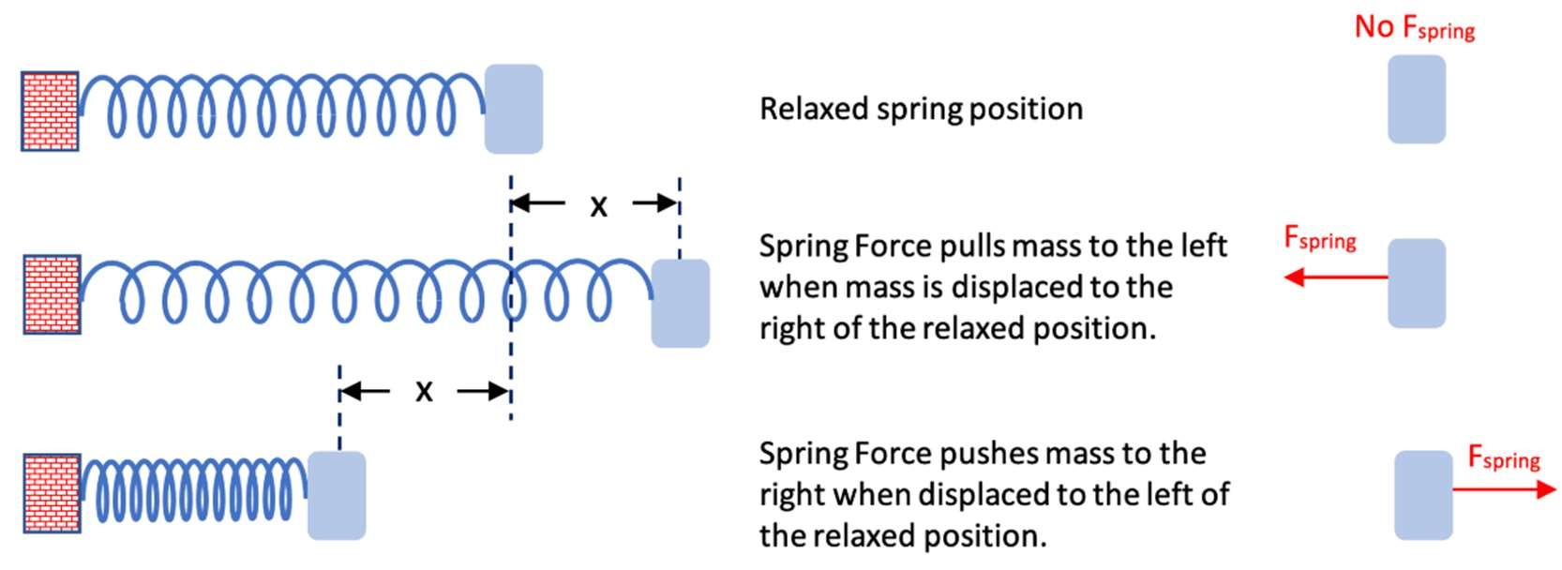

Consider an oscillating system consisting of a particle of mass m attached to a spring of spring constant K that is free to move over a frictionless horizontal surface is subjected to restoring force F such that:
𝐹 𝛼 – 𝑥
𝐹 = −𝐾𝑥 …………1
Where 𝑥 is the displacement of the particle from its equilibrium position. 𝐾 is also called the stiffness factor and its value depends on the nature of spring. It is large for a hard spring and small for a soft spring.
From 2nd law of motion
𝐹 = 𝑚𝑎
𝐹 = 𝑚 ………………. 2
From equation 1 and 2
𝑑 𝑥
𝑚 = −𝐾𝑥
𝑑𝑡
𝑑 𝑥 𝐾
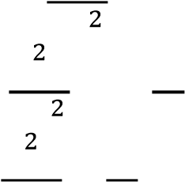
= − 𝑥
𝑑𝑡 𝑚
𝑑 𝑥 𝐾
+ 𝑥 = 0
𝑑𝑡 𝑚
Replacing = w²
The equation become, + 𝜔 𝑥 = 0
This is the equation of simple harmonic motion
The expression for displacement, velocity and acceleration of particle with SHM:
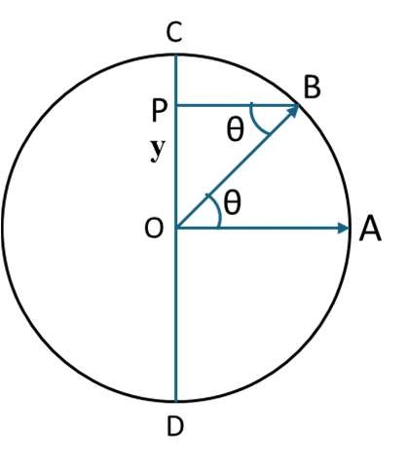
Consider a particle executing uniform circular motion along the circumference of a circle of radius A. Particle moved from A to B in time t.
As the particle goes along the circular path, the foot of the particle marks an up and down motion along the diameter CD with O as the mean position. C and D are the extreme points. Thus, the motion of shadow along the diameter CD constitutes a simple harmonic motion. From the figure, 𝜃 the angular displacement of the particle when the linear displacement along CD is y = OP.
𝑂𝑃 𝑦
𝑠𝑖𝑛𝜃 = =
𝑂𝐵 𝐴
𝑦 = 𝐴𝑠𝑖𝑛𝜃
❑
If  is the angular velocity, then  or  t
t
∴ The displacement,  y Asint
Expression for velocity and acceleration in S.H.M:
We know  y Asint
A  maximum displacement from the mean position or the amplitude.
Velocity of the particle executing SHM at any instant of time is given by
( )
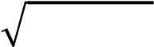
= = 𝐴𝜔𝑐𝑜𝑠𝜔𝑡 or 𝑉 = 𝜔 𝐴 − 𝑦
From the above equation it is found that the velocity of the particle executing SHM is maximum at the mean position and zero at extreme position. Max velocity 𝑣 = 𝐴
The acceleration of the particle executing SHM is given by
𝑑𝑣 𝑑(𝐴𝜔𝑐𝑜𝑠𝜔𝑡)
𝑎 = = = −𝜔 𝐴𝑠𝑖𝑛𝜔𝑡
𝑑𝑡 𝑑𝑡
𝑎 = −𝜔 𝑦
Acceleration is maximum at extreme positions and zero at the mean position Max acceleration =  𝐴.
S.H.M wave is represented by
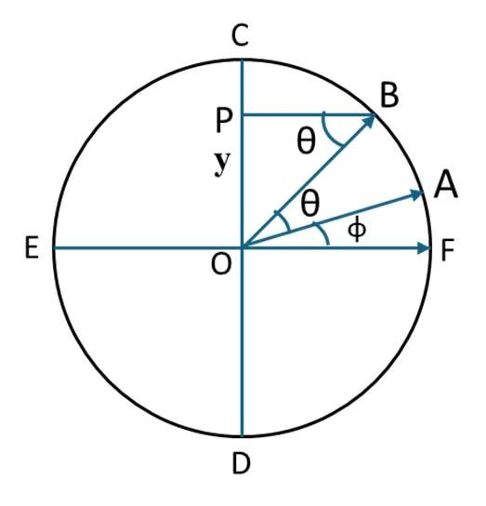
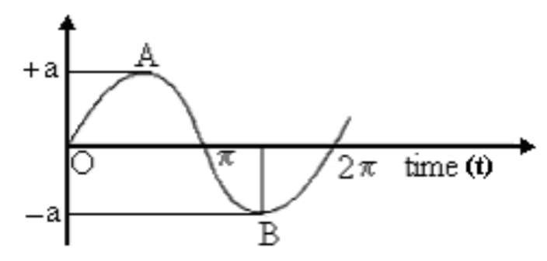
If the particle executing circular motion along the circumference of a circle of radius A with existing phase 𝜙 at initial point of the motion as shown in the figure.
Then the displacement along the diameter CD, 𝑦 = 𝐴 𝑠𝑖𝑛(𝜔𝑡 + 𝜙) and the displacement along the diameter EF, 𝑥 = 𝐴 𝑐𝑜𝑠(𝜔𝑡 + 𝜙)

Superposition of two collinear harmonic oscillations having equal frequencies:
Consider two simple harmonic oscillations of equal frequency but of different amplitudes and phase acting on a particle in x-direction.
Let 𝑥 and 𝑥 are displacements of two SHM's of same angular frequency 𝜔 are given by
𝑥 = 𝑎 cos(𝜔𝑡 + 𝜙 ) 𝑥 = 𝑏 cos(𝜔𝑡 + 𝜙 )
where a and b are the amplitudes and 𝜙 and 𝜙 are the phase respectively of two simples harmonic motion.
According to superposition principle the resultant of these two harmonic motions is given by
𝑥 = 𝑥 + 𝑥
𝑥 = 𝑎 cos(𝜔𝑡 + 𝜙 ) + 𝑏 cos(𝜔𝑡 + 𝜙 ) From trigonometric expansion, cos(𝐴 + 𝐵) = cos 𝐴 cos 𝐵 − sin 𝐴 sin 𝐵
We can write the resultant displacement as
𝑥 = 𝑎 (cos 𝜔𝑡 cos 𝛼 − sin 𝜔𝑡 sin 𝛼 ) + 𝑏 (cos 𝜔𝑡 cos 𝛼 − sin 𝜔𝑡 sin 𝛼 )
𝑥 = (𝑎 cos 𝛼 + 𝑏 cos 𝛼 ) cos 𝜔𝑡 − (𝑎 sin 𝛼 + 𝑏 sin 𝛼 ) sin 𝜔𝑡 . . . . . . . . . . . . . 1
𝑎 cos 𝛼 + 𝑏 cos 𝛼 = 𝐴 cos 𝜃 . . . . . . . . . . . . . 2 𝑎 sin 𝛼 + 𝑏 sin 𝛼 = 𝐴 sin 𝜃 . . . . . . . . . . . . . 3
Where A and 𝜃 are constants to be determined. Substituting these values in equation 1, we get
𝑥 = 𝐴 cos 𝜔𝑡 cos 𝜃 − 𝐴 sin 𝜔𝑡 sin 𝜃
𝑥 = 𝐴 cos(𝜔𝑡 + 𝜃)
This equation shows the resultant displacement is also a simple hormonic motion of amplitude A and phase difference 𝜃.
The values of A and 𝜃 can be determined from equation 2 and 3.
Squaring and adding equation 2 and 3, we et
𝐴 cos 𝜃 + 𝐴 sin 𝜃 = (𝑎 cos 𝛼 + 𝑏 cos 𝛼 ) + (𝑎 sin 𝛼 + 𝑏 sin 𝛼 )
𝐴 = 𝑎 cos 𝛼 + 𝑏 cos 𝛼 + 2𝑎 𝑎 cos 𝛼 cos 𝛼 +
𝑎 sin 𝛼 + 𝑏 sin 𝛼 + 2𝑎 𝑎 sin 𝛼 sin 𝛼
𝐴 = 𝑎 + 𝑏 + 2𝑎 𝑎 (cos 𝛼 cos 𝛼 + sin 𝛼 sin 𝛼 )
𝐴 = 𝑎 + 𝑏 + 2𝑎 𝑎 cos(𝛼 − 𝛼 )
𝐴 = 𝑎 + 𝑏 + 2𝑎 𝑎 cos 𝛼
Where 𝛼 − 𝛼 = 𝛼 is a constant phase and A the resultant amplitude.
The value 𝜃 can be obtained by dividing equation 2 and 3. Thus
𝑎 sin 𝛼 + 𝑏 sin 𝛼
tan 𝜃 =
𝑎 cos 𝛼 + 𝑏 cos 𝛼
Superposition of two collinear harmonic oscillations having different frequencies: Beats
Consider two oscillations having same amplitude a with slightly different frequencies 𝑛 and 𝑛 traveling simultaneously in medium. If 𝑦 and 𝑦 be the displacements of these oscillations at any instant t, then
𝑦 = 𝑎 sin 𝜔 𝑡 = 𝑎 sin 2𝜋𝑛 𝑡
𝑦 = 𝑎 sin 𝜔 𝑡 = 𝑎 sin 2𝜋𝑛 𝑡
Applying the principle of superposition, the resultant displacement 𝑦 at any instant 𝑡 is given by,
𝑦 = 𝑦 + 𝑦 = 𝑎 sin 2𝜋𝑛 𝑡 + 𝑎 sin 2𝜋𝑛 𝑡
𝑛 + 𝑛 𝑛 − 𝑛
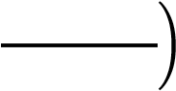
= 2𝑎 sin 2𝜋 𝑡 . cos 2𝜋 𝑡
2 2
𝑛 − 𝑛 𝑛 + 𝑛
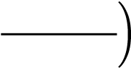
= 2𝑎 cos 2𝜋 𝑡 sin 2𝜋𝑡
2
𝑦 = 𝐴 sin 2𝜋 𝑡 . . . . . . . . . . . . 1
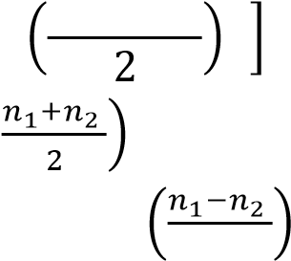
Where 𝐴 = 2𝑎 cos 2𝜋 𝑡
Equation 1 represents a simple harmonic motion whose amplitude is A and average
frequency is

Now for 𝐴 to be maximum, cos 2𝜋 𝑡 = ± 1

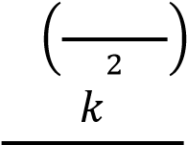
Or 2𝜋 𝑡 = 𝑘𝜋, where 𝑘 = 0. 1, 2, . . . . ..
𝑡 =
(𝑛 − 𝑛 )
When 𝑘 = 0, |  | 𝑡 = 0 |  |  | First maxima
𝑘 = 1,  𝑘 = 2, |  | 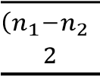  𝑡 =  𝑡 =  ( | )  ) |  | Second maxima  Third maxima
. . . . . |  | . . . . . |  |  | . . . . . .
𝑘 = 𝑛, |  | 𝑡 =  ( | ) |  | n^{th} maxima
Thus, the time interval between two successive maxima = ₍ ₎ seconds
Therefore, frequency of maxima = 𝑛 − 𝑛

Similarly, the amplitude is minimum, when
𝑛 − 𝑛
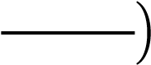
cos 2𝜋𝑡 = 0
2

Or 2𝜋 𝑡 = (2𝑘 + 1) , where 𝑘 = 0. 1, 2, . . . . ..
𝑡 = 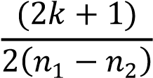
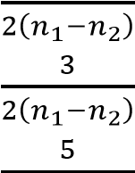
When 𝑘 = 0, 𝑡 = First minima
𝑘 = 1, 𝑡 = Second minima
𝑘 = 2, 𝑡 = ₍ ₎ Third minima
. . . . . . . . . . . . . . . .
𝑘 = 𝑛, 𝑡 = n^{th} minima
( )
Thus, the time interval between two successive minima = seconds
( )
Therefore, frequency of minima = 𝑛 − 𝑛
This shows that the frequency of minima and maxima is the same. Between any two maxima there is a minimum.
When two waves of nearly same frequency and having a constant initial phase propagate simultaneously along the same straight line and in the same direction, they superimpose and the intensity at a point increase and decreases alternatively. This phenomena of increasing and decreasing of sound is called beats.
Superposition of Two perpendicular Harmonic Oscillation
Let 𝑥 = 𝑎 𝑐𝑜𝑠(𝜔𝑡) and 𝑦 = 𝑏 𝑐𝑜𝑠(𝜔𝑡 + 𝛷) represent the displacement of a particle along the 𝑥 and 𝑦 axis due to the influence of the two simple harmonic vibrations acting simultaneously on a particle in a perpendicular direction. Here the two vibrations are of different amplitudes and different phase angles.
𝑥 = 𝑎 𝑐𝑜𝑠(𝜔𝑡) and 𝑐𝑜𝑠(𝜔𝑡) = | ….…... (1)
𝑦 = 𝑏 𝑐𝑜𝑠(𝜔𝑡 + 𝛷) and = 𝑏 𝑐𝑜𝑠(𝜔𝑡 + 𝛷) | ……... (2)
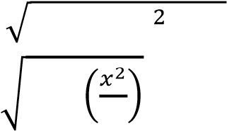
𝑠𝑖𝑛 (𝜔𝑡) = (1 − 𝑐𝑜𝑠 𝜔𝑡 )
Equation (2) can be written as  𝑦  = cos(𝜔𝑡) cos( 𝛷) − sin (𝜔𝑡)sin ( Φ)  𝑏 |  | ……….. (3)
sin(ωt) = 1 −
𝑦 𝑥
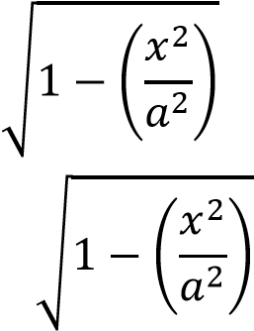
= cos Φ − sin Φ
𝑏 𝑎
𝑦 𝑥
− cos Φ = −sin Φ
𝑏 𝑎
Square on both the sides
𝑦 𝑥 2𝑥𝑦 𝑥
+ cos Φ − cos Φ = 1 − sin Φ
𝑏 𝑎 𝑎𝑏 𝑎
𝑦 𝑥 2𝑥𝑦 𝑥
+ cos Φ − cos Φ = sin Φ − sin Φ
𝑏 𝑎 𝑎𝑏 𝑎
𝑦 𝑥 2𝑥𝑦 𝑥
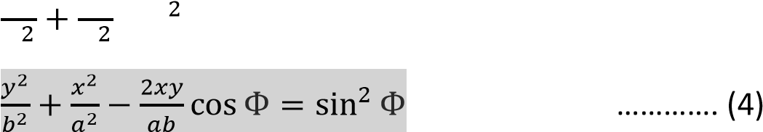
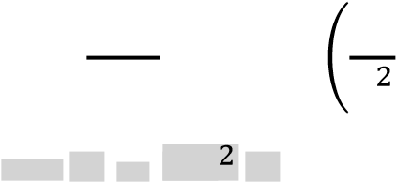
cos Φ − cos Φ + sin Φ = sin Φ
𝑏 𝑎 𝑎𝑏 𝑎
…………. (4)
Case i) when Φ = 0
𝑏𝑥
𝑦 =
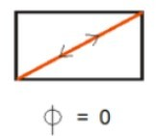
𝑦 𝑥 2𝑥𝑦
+ − = 0
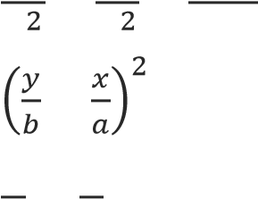
𝑏 𝑎 𝑎𝑏
− = 0
𝑦 𝑥
= ⟹
𝑏 𝑎 𝑎
𝝅
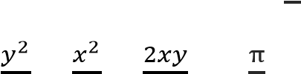
Case ii) when 𝚽 =
𝟒
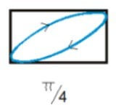
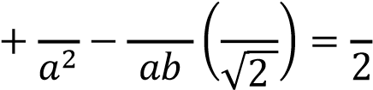
+ − cos = sin
𝑦 𝑥 2𝑥𝑦 1 1
𝑏

𝑦 | 𝑥  + | 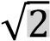  𝑥𝑦 1  − =
𝑏 𝑎 𝑎𝑏 2
𝝅
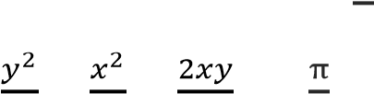
Case iii) when 𝚽 =
𝑦 | 𝑥  + = 1
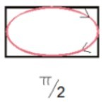
𝟐
+ − cos = sin

𝑏 𝑎
𝟑𝝅
Case iv) when 𝚽 =
𝟒
𝑦 | 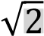  𝑥 𝑥𝑦 1  + +=
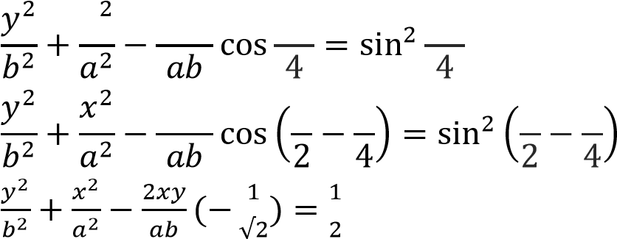
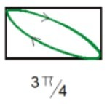
𝑥 2𝑥𝑦 3π 3π

2𝑥𝑦 𝜋 𝜋 π 𝜋

𝑏 𝑎 𝑎𝑏 2
Case v) when 𝚽 = 𝝅
𝑥𝑏
𝑦 = −
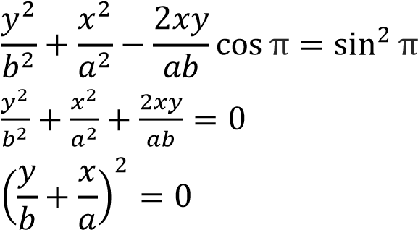
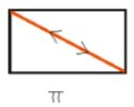
𝑎
Free vibrations with damping
When the oscillator vibrates in air medium, the frictional forces and energy is dissipated in each vibration. The amplitude of the swing decreases continuously with time and finally the oscillations die out, such vibrations are free damped vibrations. The differential equation in the free damped vibration is
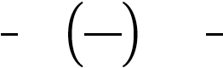
𝑚 + 𝑘𝑦 + 𝜇𝑦 = 𝑐𝑜𝑛𝑠𝑡𝑎𝑛𝑡 …….. (1)
Differentiating equation (1)
𝑚 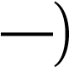 + 𝑘𝑦 + 𝜇 = 0 …….. (2)
Divide equation (2) by m
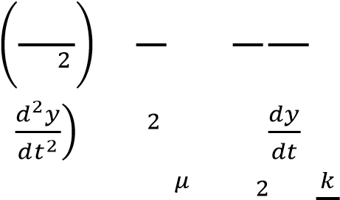
𝑑 𝑦 𝑘 𝜇 𝑑𝑦
+ 𝑦 + = 0
𝑑𝑡 𝑚 𝑚 𝑑𝑡
+ 𝑤 𝑦 + 2𝑏 = 0 …….. (3)
Where 2b = , 𝑤 =
The solution of the differential equation (3) is 𝑦 = 𝑒
= 𝛼𝑒 .……. (4)
= 𝛼 𝑒 .……. (5)
Substitute (4) and (5) in equation (3)
𝛼 𝑒 + 2𝑏𝛼𝑒 + 𝑤 𝑒 = 0
𝑒 (𝛼 + 2𝑏𝛼 + 𝑤 ) = 0
𝛼 + 2𝑏𝛼 + 𝑤 = 0
The roots for the above equation is given by
−𝑏 ± √𝑏 − 4𝑎𝑐

𝑥 =
2𝑎
−2𝑏 ± √4𝑏 − 4𝑤
𝛼 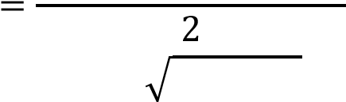
𝛼 = −𝑏 + − 𝑤
𝛼 = −𝑏 − − 𝑤
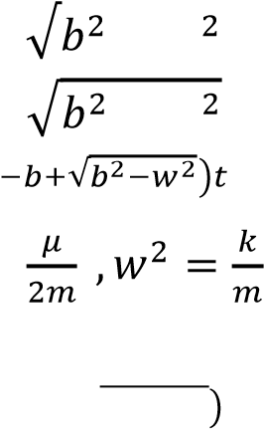
𝑦 = 𝐴 𝑒 + 𝐴 𝑒 √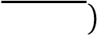
Where 𝑏 =
Case(i) when 𝒃 >> 𝒘 (over damped)
𝑦 = 𝐴 𝑒 √ + 𝐴 𝑒 √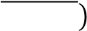
𝑦 = 𝐴 𝑒⁽ ⁾ + 𝐴 𝑒⁽ ⁾
𝑦 = 𝐴 + 𝐴 𝑒
Case(ii) When 𝒃 = 𝒘 (critically damped)
𝑦 = 𝐴 𝑒 √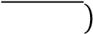 + 𝐴 𝑒 √
𝑦 = 𝐴 𝑒 + 𝐴 𝑒
𝑦 = (𝐴 + 𝐴 )𝑒
Case(iii) when 𝒃 << 𝒘 (under damped)
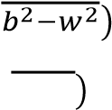
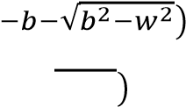
𝑦 = 𝐴 𝑒 √+ 𝐴 𝑒
𝑦 = 𝐴 𝑒 √ + 𝐴 𝑒 √
𝑦 = 𝐴 𝑒⁽ ⁾ + 𝐴 𝑒⁽ ⁾
Where 𝑤 − 𝑑𝑎𝑚𝑝𝑒𝑑 𝑓𝑟𝑒𝑞𝑢𝑒𝑛𝑐𝑦
𝛼 = −𝑏 + 𝑖𝑤
𝛼 = −𝑏 − 𝑖𝑤
𝐴 ≈ 𝐴 ≈ 𝐴
𝑦 = 𝐴 𝑒( ) + 𝑒( )
𝑦 = 𝐴𝑒 𝑒 + 𝑒
𝑦 = 2𝐴𝑒 (cos(𝑤 𝑡 + 𝜙)
Where 𝑒 + 𝑒 = 2cos (𝜃 + 𝜙)
The logarithmic ratio of successive amplitudes in one cycle is called as the logarithmic decrement given by
𝑦(𝑡)
λ = log
𝑦(𝑡 + 𝑇)
𝑦(𝑡) = 𝐴𝑒 (cos (𝑖𝑤 𝑡 + 𝜙))
𝑦(𝑡 + 𝑇) = 𝐴𝑒 ⁽ ⁾(cos(𝑖𝑤 (𝑡 + 𝑇) + 𝜙))
𝑦(𝑡 + 𝑇) = 𝐴𝑒  When 𝜙 = 0 | 𝑒 | (cos(𝑖𝑤 (𝑡 + 𝑇) + 𝜙))
𝑦(𝑡 + 𝑇) = 𝐴𝑒 | 𝑒 | cos 𝑤 (𝑡 + 𝑇)
𝑦(𝑡) = 𝐴𝑒 (cos (𝑤 𝑡))
𝑦(𝑡) 𝐴𝑒 𝑐𝑜𝑠𝑤 𝑡
=
𝑦(𝑡 + 𝑇) 𝐴𝑒 𝑒 (cos(𝑤 𝑡 + 𝑤 𝑇))
𝑤 𝑇 = 2𝜋, 𝑠𝑖𝑛𝑐𝑒 𝑐𝑜𝑚𝑝𝑙𝑒𝑡𝑒 𝑜𝑛𝑒 𝑐𝑦𝑐𝑙𝑒 𝑖𝑠 𝑐𝑜𝑣𝑒𝑟𝑒𝑑
𝑐𝑜𝑠𝑤 𝑡
𝜆 = ln
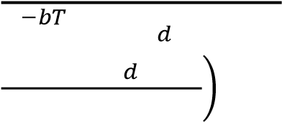
𝑒 𝑐𝑜𝑠(𝑤 𝑡 + 2𝜋)
𝑐𝑜𝑠𝑤 𝑡
𝜆 = ln
𝑒 𝑐𝑜𝑠(𝑤 𝑡)
𝜆 = ln(𝑒 )
𝜆 = 𝑏𝑇
2𝜋
𝑤 =
𝑇
𝟐𝝅
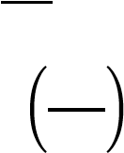
𝝀 = 𝒃
𝒘_{𝒅}
Forced vibration with damping
When a damped oscillator vibrates by being influenced by an external periodic force 𝐹𝑐𝑜𝑠(𝑤𝑡 + 𝜙), it is called forced oscillation. The differential equation in the forced damped vibration is
𝑚 + 𝜇 + 𝑘𝑦 = 𝐹𝑐𝑜𝑠(𝑤𝑡 + 𝜙) ………. (1)
Divide equation (1) by m
𝑑 𝑦 𝜇 𝑑𝑦 𝑘 𝐹
+ + 𝑦 = 𝑐𝑜𝑠(𝑤𝑡 + 𝜙)
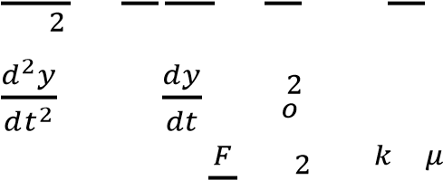
𝑑𝑡 𝑚 𝑑𝑡 𝑚 𝑚
+ 2𝑏 + 𝑤 𝑦 = 𝑓𝑐𝑜𝑠(𝑤𝑡 + 𝜙) ………. (2)
Where 𝑓 = , 𝑤 = , = 2𝑏
𝑦 = 𝑎𝑒
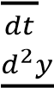
= 𝑖𝑤𝑎𝑒 ………. (3)
= −𝑤 𝑎𝑒 ………. (4)
Substitute (3) and (4) in (2)
−𝑤 𝑎𝑒 + 2𝑏𝑖𝑤𝑎𝑒 + 𝑤 𝑎𝑒 = 𝑓(𝑐𝑜𝑠𝑤𝑡 𝑐𝑜𝑠𝜙 − 𝑠𝑖𝑛𝑤𝑡 𝑠𝑖𝑛𝜙)
𝑒 (−𝑤 𝑎 + 2𝑏𝑖𝑤𝑎 + 𝑤 𝑎) = 𝑓𝑐𝑜𝑠𝑤𝑡 𝑐𝑜𝑠𝜙 − 𝑓𝑠𝑖𝑛𝑤𝑡 𝑠𝑖𝑛𝜙
We know 𝑒 = 𝑐𝑜𝑠𝑤𝑡 + 𝑖 𝑠𝑖𝑛𝑤𝑡 so the above equation can be written as
(𝑐𝑜𝑠𝑤𝑡 + 𝑖 𝑠𝑖𝑛𝑤𝑡)(−𝑤 𝑎 + 2𝑏𝑖𝑤𝑎 + 𝑤 𝑎) = 𝑓𝑐𝑜𝑠𝑤𝑡 𝑐𝑜𝑠𝜙 − 𝑓𝑠𝑖𝑛𝑤𝑡 𝑠𝑖𝑛𝜙
−𝑎𝑤 𝑐𝑜𝑠𝑤𝑡 + 2𝑏𝑖𝑤𝑎𝑐𝑜𝑠𝑤𝑡 + 𝑤 𝑎𝑐𝑜𝑠𝑤𝑡 − 𝑖𝑤 𝑎𝑠𝑖𝑛𝑤𝑡 − 2𝑏𝑤𝑎𝑠𝑖𝑛𝑤𝑡 + 𝑖𝑤 𝑎𝑠𝑖𝑛𝑤𝑡 = 𝑓𝑐𝑜𝑠𝑤𝑡𝑐𝑜𝑠𝜙 − 𝑓𝑠𝑖𝑛𝑤𝑡𝑠𝑖𝑛𝜙
[(𝑤 − 𝑤 )𝑎𝑠𝑖𝑛𝑤𝑡 + 2𝑏𝑤𝑎𝑐𝑜𝑠𝑤𝑡]𝑖 + [(𝑤 − 𝑤 )𝑎𝑐𝑜𝑠𝑤𝑡 − 2𝑏𝑤𝑎𝑠𝑖𝑛𝑤𝑡] = 𝑓𝑐𝑜𝑠𝑤𝑡𝑐𝑜𝑠𝜙 − 𝑓𝑠𝑖𝑛𝑤𝑡𝑠𝑖𝑛𝜙
Equating imaginary and real terms we get,
Imaginary term,
𝑎[(𝑤 − 𝑤 )𝑠𝑖𝑛𝑤𝑡 + 2𝑏𝑤𝑐𝑜𝑠𝑤𝑡] = 0  Real term, | ………(5)
(𝑤 − 𝑤 )𝑎𝑐𝑜𝑠𝑤𝑡 − 2𝑏𝑤𝑎𝑠𝑖𝑛𝑤𝑡 = 𝑓𝑐𝑜𝑠𝑤𝑡𝑐𝑜𝑠𝜙 − 𝑓𝑠𝑖𝑛𝑤𝑡𝑠𝑖𝑛𝜙  (𝑤 − 𝑤 )𝑎𝑐𝑜𝑠𝑤𝑡 = 𝑓𝑐𝑜𝑠𝑤𝑡𝑐𝑜𝑠𝜙 | ………(6)
(𝑤 − 𝑤 )𝑎 = 𝑓𝑐𝑜𝑠𝜙  2𝑏𝑤𝑎𝑠𝑖𝑛𝑤𝑡 = 𝑓𝑠𝑖𝑛𝑤𝑡𝑠𝑖𝑛𝜙 | ………(7)
2𝑏𝑤𝑎 = 𝑓𝑠𝑖𝑛𝜙  Dividing (8) by (7)  𝑓𝑠𝑖𝑛𝜙 2𝑎𝑏𝑤 | ..……(8)
=
𝑓𝑐𝑜𝑠𝜙 𝑎(𝑤 − 𝑤 )
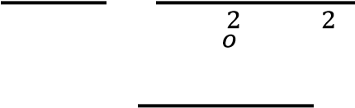
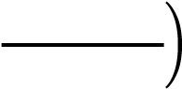
𝑡𝑎𝑛𝜙 = (𝑤 2𝑏𝑤− 𝑤 ) ⟹ 𝝓 = 𝐭𝐚𝐧 _{𝟏} 𝒘_{𝟐}𝟐𝒃𝒘_{− 𝒘}𝟐
_{𝒐}
Square and add equation (7) and (8)
𝑓 cos 𝜙 + 𝑓 sin 𝜙 = 𝑎 4𝑏 𝑤 + 𝑎 (𝑤 − 𝑤 )
𝑓 = 𝑎 (4𝑏 𝑤 + (𝑤 − 𝑤 ) )
𝑓
𝑎 =
(4𝑏 𝑤 + (𝑤 − 𝑤 ) )
𝑓
𝑎 =
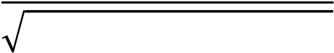
4𝑏 𝑤 + (𝑤 − 𝑤 )
At resonance, 𝑤 = 𝑤
𝒇
𝒂 =
𝟐𝒃𝒘
RESONANCE
If we bring a vibrating tuning fork near another stationary tuning fork of the same natural frequency as that of vibrating tuning fork, we find that stationary tuning fork also starts vibrating. This phenomenon is known as resonance.
The phenomenon of making a body vibrate with its natural frequency under the influence of another vibrating body with the same frequency is called resonance.
The examples of resonance are:
- Tuning of a radio or transistor, when the natural frequency is so adjusted, by moving the tuning knob of the receiver set that it equals the frequency of the radio waves, the resonance takes place and the incoming sound waves can be listened after being amplified.
- Musical instruments can be made to vibrate by bringing them in contact with vibrations which have a frequency equal to the natural frequency of the instruments.
- Soldiers crossing a suspension bridge are prohibited to march in steps and are advised to march on the suspension bridge out of steps so as to avoid the resonance between the natural frequency of the bridge and the natural frequency of the steps of soldiers which may cause the collapse of the bridge.

Condition of Resonance
In case of forced vibrations, we have
𝑓
𝑎 =
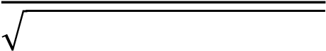
4𝑏 𝑤 + (𝑤 − 𝑤 )
At resonance, 𝑤 = 𝑤
𝒇
𝒂 =
𝟐𝒃𝒘
Sharpness of the resonance:
The term sharpness of resonance means the rate of fall in amplitude, with the change of forcing frequency on each side of resonance frequency.

i.e. Sharpness of resonance =

Thus, Sharpness of Resonance depends Inversely on 𝑏(∝ 𝜇)
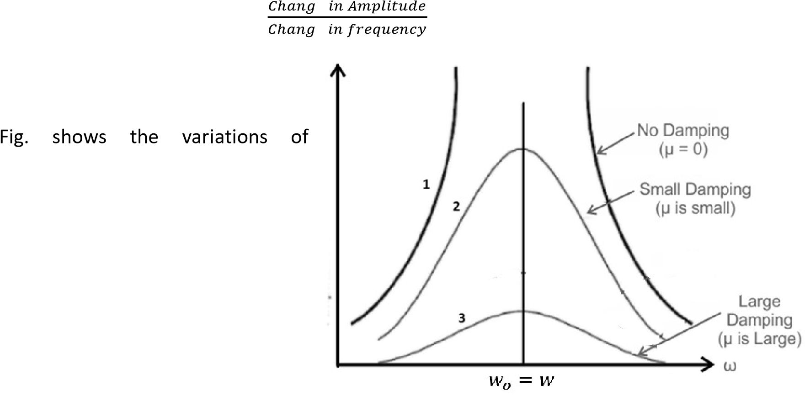
Fig. shows the variations amplitude with forcing frequency at different amounts of damping. Curve (1) shows the amplitude when there is no damping i.e. 𝑏 = 0. In this case the amplitude becomes infinite at 𝜔 = 𝜔 . This case is never attained in practice due to frictional resistance, as slight damping is always present. Curves
(2) and (3) show the effect of damping on the amplitude, which is different for different values of 𝑏 (damping), diminishes as the value of 𝑏 increases. This shows that smaller is the value of damping, greater is the departure of amplitude of forced vibration from the maximum value and vice versa. Hence smaller is the damping, sharper is the resonance or large is the damping, flatter is the resonance.

Wave equation and its solution
The general equation for a plane progressive wave is given by
𝑦 = 𝑎 sin 2 𝜋(^{𝑡} 𝑇 − ^{𝑥} 𝜆)
Which can also be written as 𝑦 = 𝑎 sin 2 𝜋(𝜔𝑡 − 𝑘𝑥)
Where 𝜔 represents angular frequency, 𝜔 ^{= 2𝜋} 𝑇 = 2𝜋𝑓 and 𝑘, wave vector, 𝑘 ^{= 2𝜋} 𝜆.
The ratio of these factors gives the phase velocity, 𝑣 , which is also called as wave velocity.
𝜔 2𝜋𝑓
= = 𝑓𝜆 = 𝑣
𝑘 2𝜋
𝜆
This essentially means the velocity with which a plane progressive wave front travels forward. It has a constant phase = 𝜔𝑡 − 𝑘𝑥
𝜔𝑡 − 𝑘𝑥 = constant
Upon differentiation,
𝜔 − 𝑘 = 0
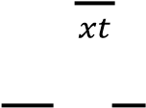
𝑑𝑥 𝜔
= = 𝑣
𝑥𝑡 𝑘
Group velocity
When we consider a group of progressive waves with angular frequencies in the range 𝜔 and 𝜔 + Δ𝜔 and wave vectors 𝑘 and 𝑘 + Δ𝑘 superimposing on one another, the resultant wave pattern consists points of maximum amplitude, points of minimum amplitude and also with varying amplitudes.

Individual Waves Amplitude variation after Superposition
A group of two or more waves, slightly differing in wavelengths are super imposed on each other. The resultant wave is a packet or wave group. The velocity with which the envelope enclosing a wave group is transported is called Group Velocity.
Expression for group Velocity:
Let y₁ = Asin(t kx- )…… (1) and y₂ = Asin   t-k+ k x   …….. (2)
The two waves having same amplitude & slightly different wavelength, where y₁ & y₂ are the displacements at any instant t, ‘A’ is common amplitude,  & k is difference in angular velocity and wave number are assumed to be small. ‘x’ is the common displacement at time ‘t’
By the principle of superposition
y =y₁+y₂=Asin(t kx- )+Asin  t-k+ k x  
a b  a b 
But, sinasinb 2cos sin 
 2   2 
    k    2    2k k  
y  2Acos 2 t  2 xsin  2 t  2 x
Since  and k are small
2   2 and2k k 2k
    k  
y  2Acos 2 t  2 xsint kx ……………………… (3)
From equations (1) & (3) it is seen the amplitude becomes
   k  
2Acos 2 t  2 x
The velocity with which the variation in amplitude is transmitted in the resultant wave is the group velocity.
(    vgroup  
( k k
 d
In the limit 
k dk
d
vgroup 
dk
Dispersion of waves
Dispersion of waves refers to the phenomenon where different wavelengths (or frequencies) of a wave travel at different speeds within a medium, causing a wave packet to spread out over time.
Example: light passing through a prism (chromatic dispersion), its components separate based on their speeds Interference
Linear superposition
When two or more waves come together, they will interfere with each other. This interference may be constructive or destructive. If you take two waves and bring them together, they will add wherever a peak from one matches a peak from the other. That's constructive interference (shown in Figure 1). Wherever a peak from one wave matches a trough in another wave, however, they will cancel each other out (or partially cancel, if the amplitudes are different); that's destructive interference (shown in Figure 2).
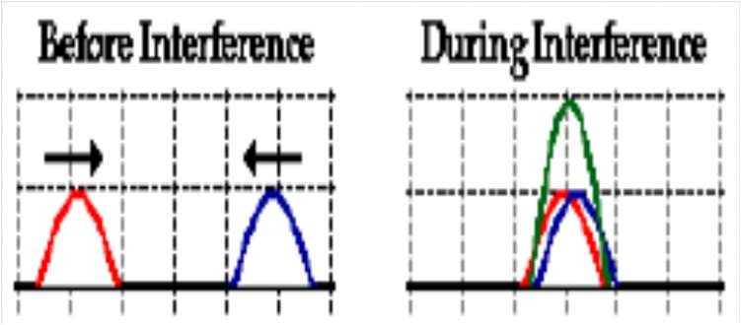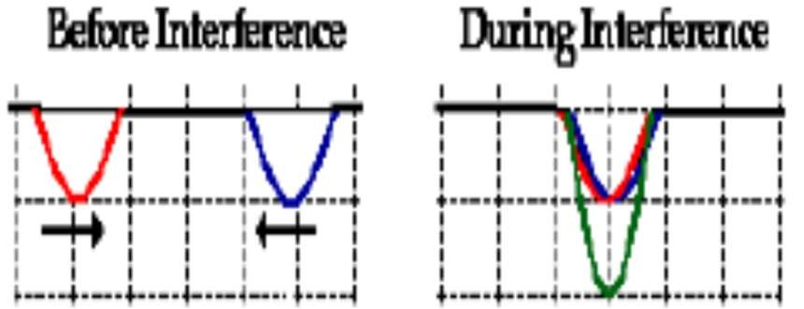

Figure 1. Constructive interference
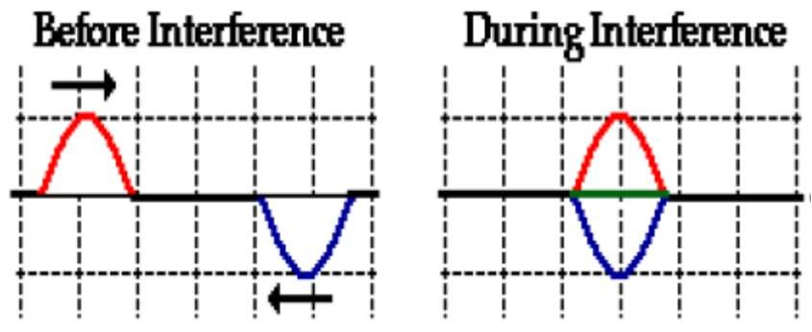
Figure 2. Destructive interference
The most interesting cases of interference usually involve identical waves, with the same amplitude and wavelength, coming together. Consider the case of just two waves, although we can generalize to more than two. If these two waves come from the same source, or from sources that are emitting waves in phase, then the waves will interfere constructively at a certain point if the distance traveled by one wave is the same as, or differs by an integral number of wavelengths from, the path length traveled by the second wave. For the waves to interfere destructively, the path lengths must differ by an integral number of wavelengths plus half a wavelength.
Condition for constructive Interference: Path length difference,
𝐩𝐚𝐭𝐡 𝐝𝐢𝐟𝐟𝐞𝐫𝐞𝐧𝐜𝐞 = 𝒎 (𝒎 = 𝟎, 𝟏, 𝟐, 𝟑. . )
Condition for destructive Interference: Path length difference,
𝐩𝐚𝐭𝐡 𝐝𝐢𝐟𝐟𝐞𝐫𝐞𝐧𝐜𝐞 = 𝒎 + ^{𝟏} 𝟐  (𝒎 = 𝟎, 𝟏, 𝟐, 𝟑. . )

Diffraction
When waves encounter obstacles (or openings), they bend round the edges of the obstacles, if the dimensions of the obstacles are comparable to the wavelength of the waves. The bending of waves around the edges of an obstacle is called diffraction.
The following figure illustrates the passage of waves through an opening. When the opening is large compared to the wavelength, the waves do not bend round the edges. When the opening is small, the bending round the edges is noticeable. When the opening is very small, the waves spread over the entire surface behind the opening. The Opening acts an independent source of waves, which propagate in all directions. The diffraction effect is observable quite close to the opening when the size of the opening is very small. When the opening is large, diffraction effect is observed at greater distances from the opening. In general diffraction of waves becomes noticeable only when the size of the obstacle is comparable to a wavelength.

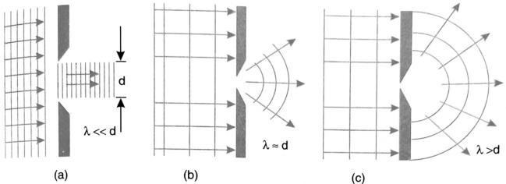
- A plane wave does not bend at the slit if the opening 𝒅 ≫ λ
- Bending is perceptible when 𝒅  λ
- When, 𝒅 < λ, the bending of light can be perceived in a direction normal to the ray propagation suggesting that the opening acts as a point source.
Distinction between Fresnel and Fraunhofer diffraction:

Fresnel diffraction | Fraunhofer diffraction
If the source of light and screen are at finite distance from the obstacle, then the diffraction is referred to as Fresnel diffraction. | If the source of light and screen are at infinite distance from the obstacle then the diffraction is referred to as Fraunhofer diffraction.
To obtain Fresnel diffraction, zone plates are used. | To obtain Fraunhofer diffraction, the single- double plane diffraction grafting is used.
Incident wavefronts are spherical. | Incident wavefronts on the diffracting obstacle are plane.
Wavefronts leaving the obstacle are also spherical. | Diffraction obstacle gives rise to wavefronts which are also plane.
The convex lens is not required to converge the spherical wavefronts. | Plane diffracting wavefronts are converged by means of a convex lens to produce a diffraction pattern.
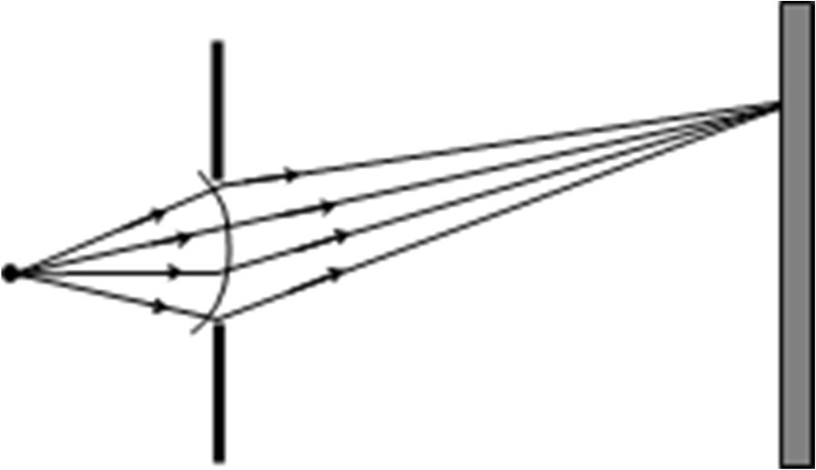 | 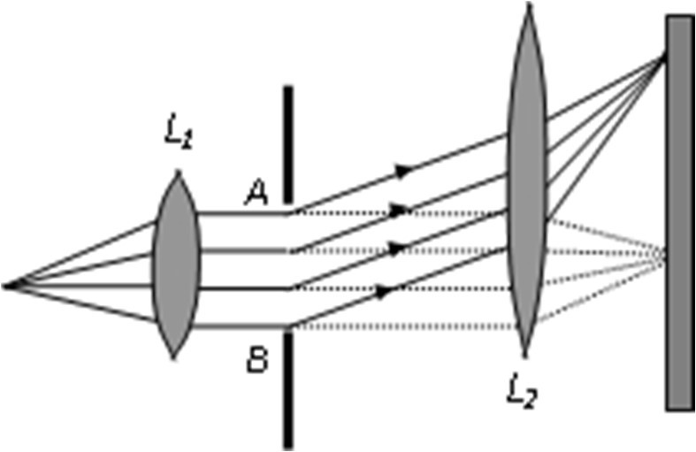

Fraunhofer Diffraction at a single Slit:

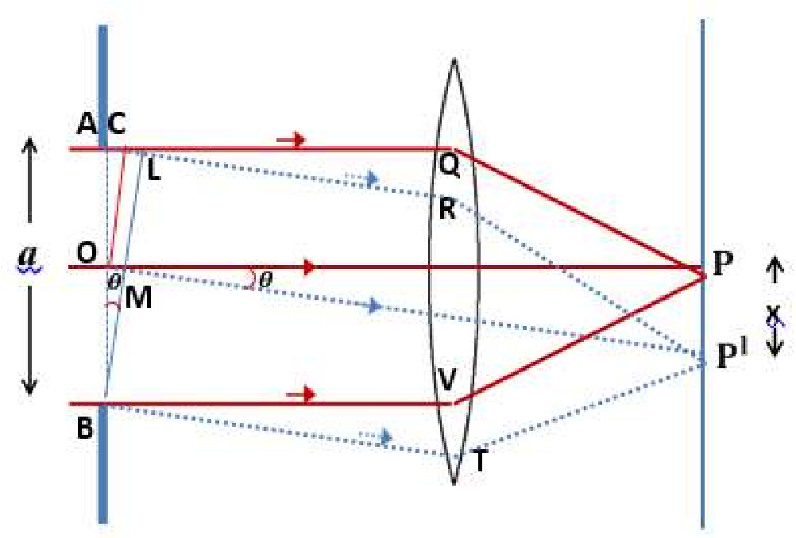
A Plane wave front incident on the slit AB and each point on this wave front is a source of secondary disturbance. The secondary waves traveling in the direction parallel to OP viz. AQ and BV come to focus at P and a bright central image is observed. The secondary waves from points equidistant from O and situated in the upper and lower halves OA and OB of the wave front travel the same distance in reaching P and hence the path difference is zero. The secondary waves reinforce one another and P will be a point of maximum intensity.

Now consider the secondary waves traveling in the direction AR. inclined at an angle to the direction OP. All the secondary waves traveling in this direction reach the point Pon the screen. The point Pwill be of maximum or minimum intensity depending on the path difference between the secondary waves originating from the corresponding points of the wave front. Let us draw OC and BL perpendicular to AR.

Then in ∆ABL, sin= =  AL = 𝑎 sin
where a is the width of the slit and AL is the path difference between the secondary waves originating from A and B. If this path difference is equal to the wavelength of the light used, then P will be a point of minimum intensity.

(The whole wave front can be considered to be of two halves OA and OB and if the path difference between the secondary waves from A and B is λ , then the path difference between the secondary waves from A and O will be 𝜆/2 . Similarly, for every point in the tipper half OA, there is a corresponding point in the lower half OB, and the path difference between the secondary waves from these points is 𝜆/2. Thus, destructive interference takes place and the point P will be of minimum intensity. If the direction of the secondary waves is such that AL = 2λ , then also the point where they meet the screen will be of minimum intensity. This is so because the secondary from the corresponding points of the lower half differ in path by 𝜆/2 . And this again gives the position of minimum intensity.)
In general, condition for minimum intensity at a point on the screen is given by 𝑎 sin = 𝑛𝜆

⇒ sin =
Where  gives the direction of the n^{th} minimum, Here n is an integer. If the path difference is odd multiples of 𝜆/2, the directions of the secondary maxima can be obtained. In this case
( )
𝑎 sin = (2𝑛 + 1) 𝜆/2  sin =

Thus, the diffraction pattern due to a single slit consists of a central bright maximum at P followed by secondary maxima and minima on both the sides, as shown in figure. P corresponds to the position of the central bright maximum and the points on the screen for which the path difference between the points A and B is λ, 2λ etc. correspond to the position of secondary minima. The secondary maxima are of much less intensity. The intensity falls off rapidly from the point P outwards.

If the lens is very near the slit or the screen is far away from the lens then,

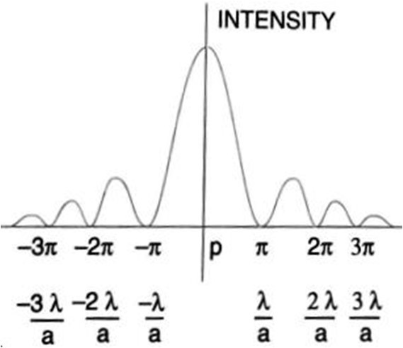
𝑥
sin=
𝑓
where f is the focal length of lens. But from the figure,
𝜆
sin=
𝑎

 = or 𝑥 =

Where x is the distance of the secondary minimum from the point P Thus, the width of the central maximum ω = 2 x
or 𝜔=

